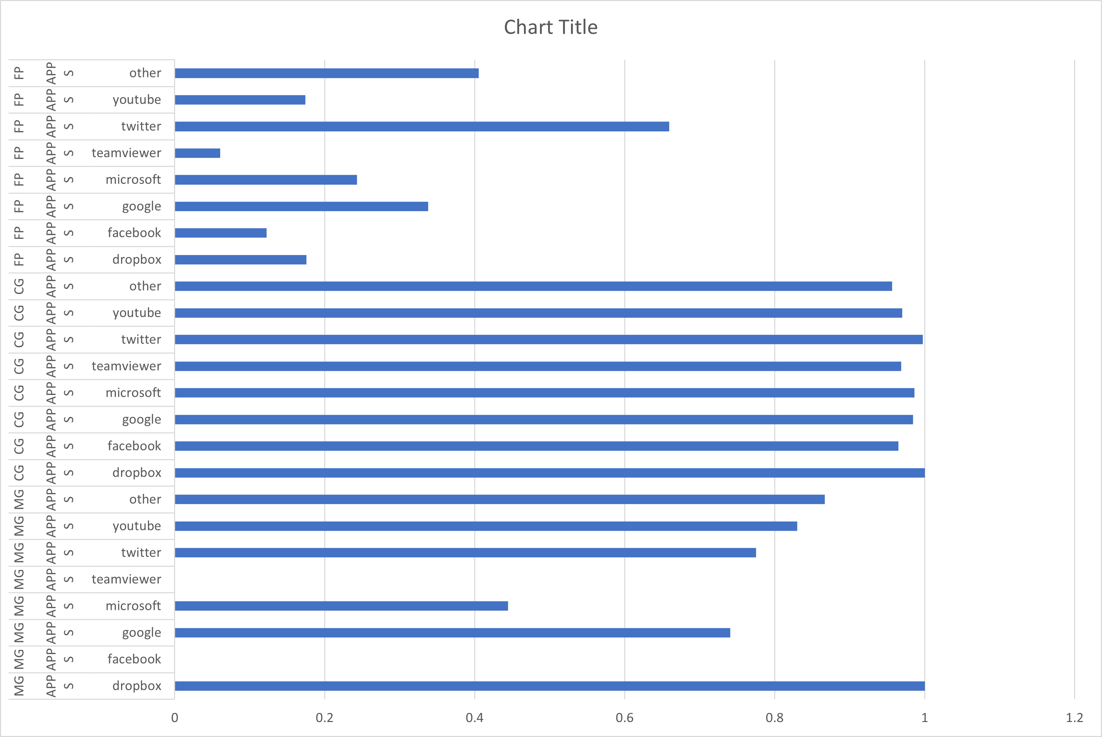Explanation of the results

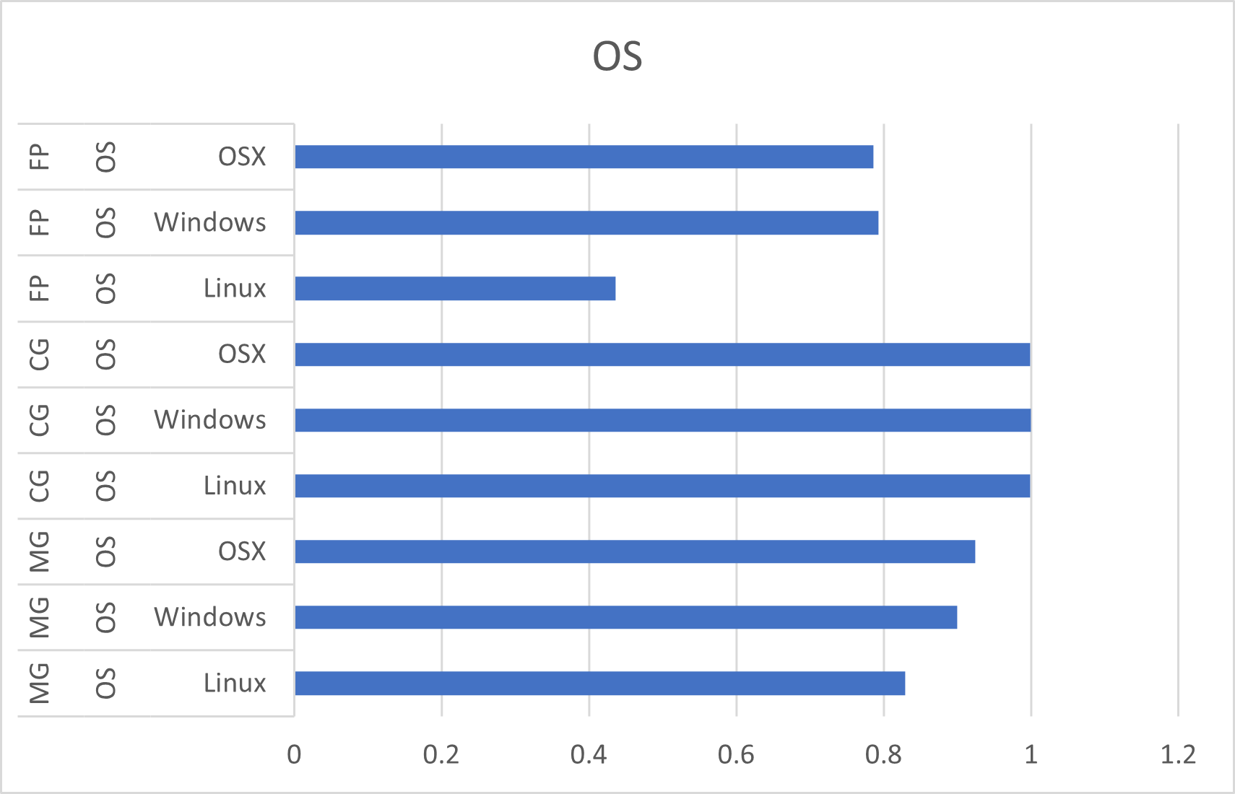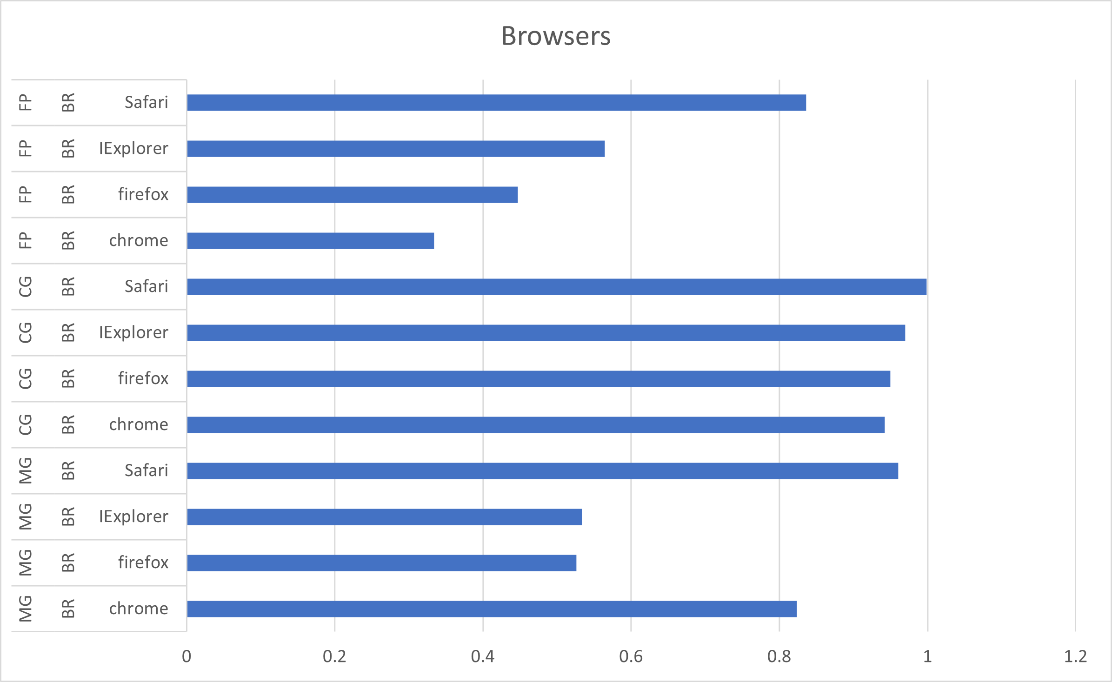  
  
  
  
  
  
  
  
  
  
  
  
  
  
  
  
  
  
  
  
  
  
  
  
  
  
  
  
  
  
  
  
  
  
  
  
  
  
  
  
  
  
As can be seen from the results above it came as no surprise for us that the MAppGraph achieved better results in every category compared to the Flow Print model on the BOA data set, since the writers have already stated this in their paper. This means that they’re results are replicable and indeed are correct.   
Another thing that can be seen from the results above is that the CGNN model clearly beats the other two models, as it has better results in every category.   
We perceived that the CGNN model outperforms the MappGraph model, even though it seems that the MAppGraph model builds a graph in a more meaningful way. The results can be explained by the fact that the MAppGraph model aggregates the flows in the BOA datasets whereas the CGNN doesn’t, something that makes the MAppGraph model have less examples for some of the classes or even throw them away. We believe that this is the sole reason for the outperformance of CGNN over the MAppGRaph. In order to truly evaluate this hypothesis, we need to run the CGNN model over the MAppGraph data.

Non the less from the results above we can conclude that the method of GNN performs better and gives better results in encrypted traffic classification.